Leading with Ethics & Integrity: Effective Decision Making
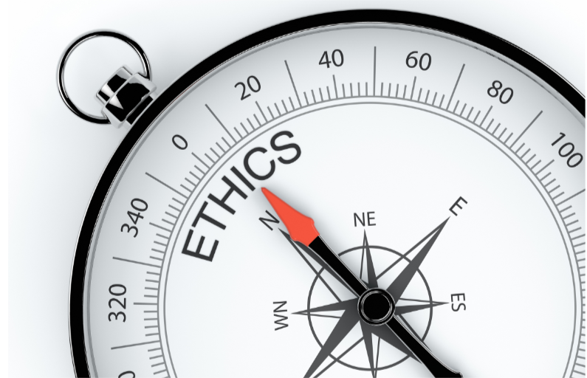

“The first law of Leadership is that your foundation is built through integrity, character & trust”
-Brian Cagneey

Here are two real-life examples to bring this concept to life:
In 2015, Volkswagen faced a major ethical crisis when it was revealed that the company had installed software to cheat emissions tests in its diesel vehicles. Under CEO Matthias Müller, Volkswagen responded by taking full accountability, recalling millions of cars, & committing to a multi-billion-dollar fund for environmental improvements & legal settlements. By prioritizing long-term ethical reforms over short-term financial impacts, Volkswagen aimed to rebuild trust & demonstrate a commitment to ethical standards.
In 1982, Johnson & Johnson faced a major ethical crisis when several bottles of Tylenol were tampered with, resulting in the deaths of seven people. This incident, known as the "Tylenol crisis," posed a significant threat to the company's reputation & customer trust. What was their response? Under the leadership of their CEO James Burke, they decided to recall 31 million bottles of Tylenol from store shelves nationwide, even though this move was costly & could potentially damage the company’s reputation. The company openly communicated the issue to the public & provided regular updates on their actions, restoring consumer confidence & posing as a benchmark for crisis management in the industry.

Why are Ethics & Integrity important?
What do the above two illustrations teach you about Leadership? What do you think the outcome would be if Matthias Müller & James Burke left the situation as it is or tried to cover it up? Would they have been successful?
The answer is a straight NO! Companies that uphold strong ethical standards typically see a 20% boost in employee retention rates. On the other hand, ethical leadership alone has the potential to boost employee morale by as much as 30%.
Ethics & integrity are fundamental to effective leadership as they build trust, foster a positive culture, guide sound decision making, protect the organization’s reputation, promote accountability, & support resilience during challenges. Leaders who embody these qualities not only enhance their own effectiveness but also contribute to the overall success & sustainability of their organizations.

How do Ethics & Integrity influence Leadership?
- Trust & Credibility
Ethical leaders foster trust by consistently adhering to moral principles & making decisions transparently. This trust is essential for strong, collaborative relationships within teams & with external stakeholders. A leader’s integrity builds credibility, ensuring that their actions & words align. This consistency reinforces their reliability & reinforces their authority.

- Improving Workplace Culture
Workplaces with strong ethical cultures often experience a 25% reduction in turnover rates. Leaders set the tone for organizational behavior. The leaders who prioritize ethics contribute to a positive organizational culture where ethical behavior is encouraged & rewarded. This creates a supportive environment that enhances employee satisfaction & retention. Also, ethical leaders influence others to follow their practices & help to cultivate an overall ethical workplace culture.

- Aids in Making Sound Decisions
Ethics provide a framework for making difficult decisions, ensuring that leaders consider the broader implications of their choices & act in ways that align with core values. Ethical decision making also often involves considering the long-term impact of actions rather than short-term gains, which helps in sustaining organizational success & reputation.

- Protecting Reputation & Reliability
An organization’s reputation is a vital asset. Ethical leadership helps protect & enhance this reputation by ensuring that actions & policies are fair, transparent, & aligned with societal expectations. When a leader upholds ethical standards, it builds confidence among customers, investors, & partners, which is crucial for maintaining strong business relationships.

- Promoting Accountability & Transparency
Ethical leaders hold themselves & others accountable for their actions, which fosters a culture of responsibility & integrity. Leaders who act ethically are open about their decisions & processes, which helps to build trust & prevent misunderstandings or misconduct.

How to develop ethical leadership skills?
- Develop Self-Awareness
Understand your values & take time to reflect on them. Knowing what you stand for helps you make consistent ethical decisions. Also, regularly seek feedback from your peers, mentors & team members for self-improvement.

- Learning & Development
Participate in workshops & training programs focused on ethics & integrity. These can provide frameworks for understanding ethical practices & practical tools for making ethical decisions.

- Emotional Intelligence
Firstly, cultivate empathy to better understand the perspectives & needs of others which helps in making decisions that consider the well-being of all stakeholders. Secondly, practice self-control & emotional regulation to handle stress & pressure without compromising your ethical standards.

- Set Clear Ethical Guidelines
Stay true to your own principles even when things are difficult. This all starts with setting clear standards & guidelines which will help you to not compromise with them in any situation.

- Cultivate a Habit of Ethical Decision-Making
Once you have established clear guidelines for yourself, make sure to stick to them. Make it a habit to follow ethics in every decision you make. This will help you to weigh the long-term consequences of your decisions on all stakeholders, not just immediate benefits.

Ethics & integrity are not just abstract principles but practical necessities for effective leadership. Employees who demonstrate strong work ethics are typically 15% more productive than their peers which makes it even more important to practice ethics at the workplace.
Developing ethical leadership skills is a continuous process that involves self-awareness, education, & practical experience. They shape every part of leadership, from making decisions to building relationships, making sure leaders act with integrity & make a real difference.
At BlewMinds, we promote a culture where ethics is valued & promoted. Connect with our coaches & develop your leadership qualities. Visit our website right now.

Keywords: Challenge | Integrity | Emotional Intelligence | Influence | Decision Making
Focus: Decision Making
Meta Description: Leaders who embody ethics & integrity contribute to the overall success of their organizations with clear decision making. Learn how.

